Name: _____________________ Section: ________ Date: ___________
Use the following video to help you create your super secure passphrases/passwords.
https://youtu.be/1kkkMVdPkbY
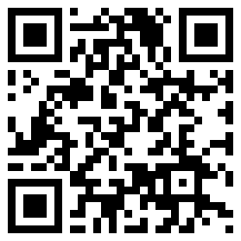
You will need one dice, a Diceware list:
http://bmstechedu.weebly.com/uploads/1/8/0/8/18089205/dicewarewordlist.pdf
And this answer sheet to help you get started.
Grading
Make 4 Passphrases = 80% (B)
Make 5 Passphrases = 90% (A)
Make 6 Passphrases = 100 (A+)
Diceware Passphrase / Password #1

Diceware Passphrase / Password #2

Diceware Passphrase / Password #3

Diceware Passphrase / Password #4

Diceware Passphrase / Password #5

Diceware Passphrase / Password #6

