You may write on the back of this sheet!
(Optional) watch the video:
https://www.youtube.com/watch?v=EkNdrTZ7CG4

Assignment:
- Read the following article.

- Write a 4 sentence summary of the article. Take care to include only factual information and not to include your opinion in the summary.

- Write a 4 sentence reaction to the article. Do you agree with the information presented? How do you feel about the topic.

- Create 3 multiple choice questions about the article. Circle the correct answer.

- Create 3 True/False statements from the article. Identify if the statements are true or false.

- Turn in this sheet and your completed assignment.

Tree-planting drones to speed up reforestation efforts

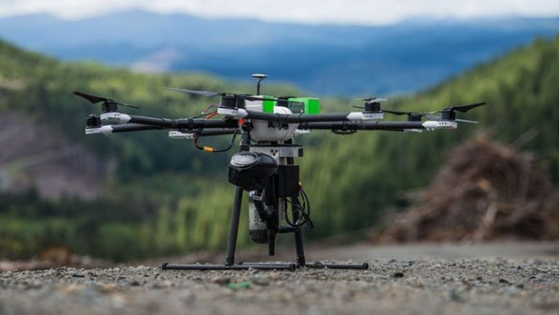

Planting trees in remote forest locations is a slow, laborious process that still relies on humans with shovels to do all the work. DroneSeed, a company based in the Pacific Northwest, wants to drastically modernize that process by employing squadrons of drones to plant seeds, spray for invasive species, and monitor the tree growth process.

Forests are important for mitigating the effects of climate change, acting as carbon sinks that absorb as much as 30 percent of annual CO2 emissions. Logging can also be a means to sequester carbon, with wood products in some cases a substitute for fossil-fuel heavy materials such as concrete and steel. Either way, trees need planting, and DroneSeed works with both forestry companies to reforest logged areas, and environmental NGOs to combat deforestation.

In the case of timber companies that work about 7 million acres in Washington, the state requires successful reforestation of 190 healthy trees planted per acre within three years after harvest. Otherwise, a forest can take 100 to 300 years to rebuild naturally to its previous state, where mature, towering trees like Douglas fir are dominant.

But managing forests is difficult in places like the Pacific Northwest, with terrain too steep and rough for machinery to navigate. The drones could go almost anywhere in this region, 3D mapping the terrain and identifying micro-sites that give seeds the best opportunity for taking root and developing into healthy trees.

The drones would first apply herbicides to clear previously logged land of grasses and brush that would otherwise choke off young tree saplings. Spraying is currently done rather messily via helicopter, or through slow, laborious manual labor. DroneSeed's drones can carry an 11-liter container of liquid and spot spray within two centimeters of GPS coordinates.

Loaded with a batch of seeds, the drones would then fly to specified sites and fire a seed into the ground at a rate of 350 feet per second (384 km/h) using compressed air. According to the company, a drone could plant up to 800 seeds per hour, compared to 800 seeds a human can plant in a day, covering an acre (0.4 ha) of forest in 1.5 hours on a full battery charge.

Besides speeding up the process while drastically reducing costs, as most robots do, in this case the human labor it replaces is a good thing. Forestry and logging is a physically demanding job and one of the most dangerous on the planet, while such companies have had an increasingly difficult time finding and retaining workers.

The company is currently going through a permission process to be able to apply herbicides, and hopes to be up and operating sometime in the coming months.

